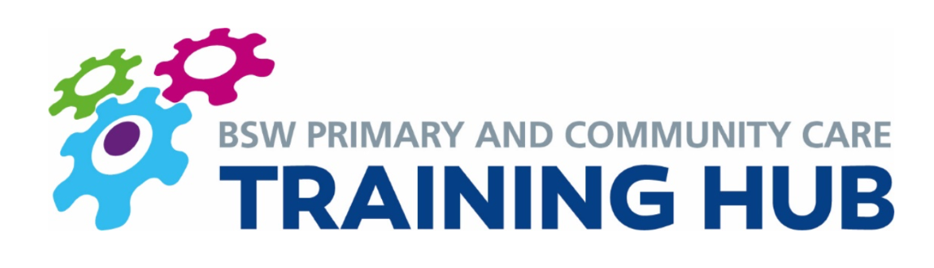
BSW Newly Qualified GP Fellowship Scheme

BSW Training Hub continue to offer a Newly Qualified GP scheme to support all newly qualified GPs within Bath, Swindon and Wiltshire. This scheme facilitates their ongoing CPD learning and supports them during the transition in becoming an independent practitioner. It is open to all NQGPs who have recently qualified.

The BSW NQGP scheme offers the following;

1) Induction / BSW GP Starter Pack
- This resource pack aims to help equip GPs with the information they need to transition smoothly into life as a newly qualified GP. The BSW GP starter pack can be found here https://bswtraininghub.nhs.uk/wp-content/uploads/2019/09/BSW-GP-Starter-Pack.pdf
- The first session of the First 5 course (please see below) is also designed to support GPs in the transition from training to employment.

2) Peer-to Peer support
  - First 5 course – This course is one session a month for a year. It is led by facilitators with a wealth of experience of medical education and is designed to offer support for your first year as a GP. It is also a great opportunity to meet other newly qualified GPs (NQGPs) in the area. Currently it is mostly run virtually but a couple of sessions through the year are held face-to-face. This has been in Devizes.
  - NQGP WhatsApp Group – All of the NQGPs in the BSW region have the option of being a part of our WhatsApp group. This is a great place to ask questions, share resources and access lots of support from other peers. Smaller WhatsApp groups also inevitably form from your First 5 course groups meaning you can keep in touch with a smaller more familiar network of NQGPs too.
  - Action Learning Set Groups – After the 12 months of the First 5 course have finished, the same groups meet monthly as before but with one of your fellow NQGPs facilitating. Action learning sets are a way of helping to work through any problems or dilemmas people would like to talk through and it’s a great opportunity to keep in touch with everyone
  - Problem Based Learning (PBL) Group – Once a month a PBL group is led by two experienced GPs and is open for all NQGPs to attend.

3) Education Trust Membership
  - All NQGPs will be offered 2 years paid membership to their local education trust. This will be delivered through SET (for Swindon GPs), and BGPERT (for B&NES and Wilts GPs). Being embedded in the local GP education systems is foundational to any GPs ongoing learning and CPD.

4) Mentorship and coaching
  - There will be provision for an experienced GP mentor (accredited with the European mentoring and Coaching Council) to link with each new GP over the course of the 2 years who can offer a minimum of six one-hour sessions.
  - The First 5 course mentors will also provide support, direction, and an objective view on how each GP can develop and progress in their clinical environment.

5) Portfolio Work
- Each GP is given up to 1 paid session (4 hours) per week (or pro-rata equivalent) fellowship time. The First 5 course or Action Learning Sets make up one of these sessions per month. The other sessions are dedicated time that are given to pursue portfolio working or can be spent joining the PBL group or other courses and events advertised by the fellowship scheme.
- We encourage at least 3 months over the 2 years to be used for engaging with the local PCNs, to see how they work and give new GPs experience of being part of the team that develops strategies for the local healthcare systems. This could also be a great way for a GP Fellow to lead on a specific project within the PCN if there is an area that they are particularly interested in.

6) Access to funded courses
- Each GP is offered a yearly GP update course where the course fees are paid for by the fellowship scheme.
- GPs may spend some of their fellowship time attending courses and events run by the Primary Care Academy. The Primary Care Academy provide a series of half day workshops to help develop skills and support newly qualified GPs across the southwest regions. ​

The hope is for the BSW NQGP Fellowship Scheme to offer a comprehensive support and learning network over the 2 years for our new GPs.

If you have any questions or for GPs interested in joining the scheme, please email bswicb.traininghub@nhs.net.

Please see FAQ sheet for answers to frequently asked questions

